Body Cavities – Front View
Label the following on the body cavities below: Abdominopelvic cavity, mediastinum, ventral cavity, diaphragm, vertebral canal, cranial cavity, pericardial cavity, abdominal cavity, pleural cavity, and pelvic cavity.

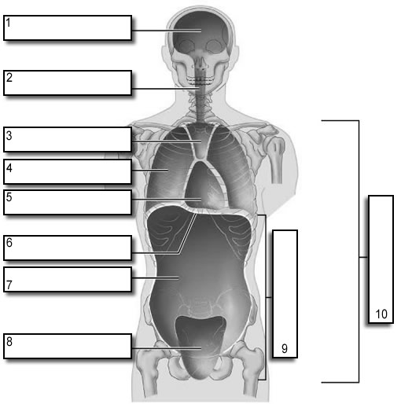

Body Cavities – Side View

Label the following on the body cavities below: dorsal cavity, diaphragm, vertebral canal, cranial cavity, thoracic cavity, abdominal cavity, and pelvic cavity.

