Chapter 1: Introduction to Anatomy and Physiology Notes
- _______________________ is the structure of body parts (also called _________________________). ______________________ is the function of body parts; what they do and how they do it.
- There are five main characteristics of living things:
(1) ____________________ – self initiated change in position; the motion of internal parts
(2) ___________________ (irritability) – ability to sense changes within, or around the organism and react to them
(3) ___________ - increase in body size
(4) ____________________ – Parents produce offspring/ producing new individuals
(5) _________________ – Obtaining oxygen (O₂), using it to release energy from food substances, and getting rid of wastes
3. There are several biological processes you need to know that occur in the body:
- ____________________ – Chemically changing (breaking down) food substances, and getting rid of wastes
- ___________________ – Passage of digested products (food substances) through membranes and into body fluids
- ____________________ – movement of substances throughout the body
- ____________________ – Changing absorbed substances into chemically different substances
- _______________ – removal of wastes
- ______________________ – all the physical and chemical changes
Bodily needs = ____________, ________________, ______________, __________________
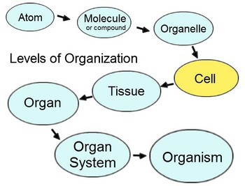
_____________________ – the tendency of the body to maintain a stable, balanced, internal environment; “sameness”

- Levels of Organization of the Body:
Atoms → Molecules → Cells → Tissue → Organs → Organ Systems → Organisms

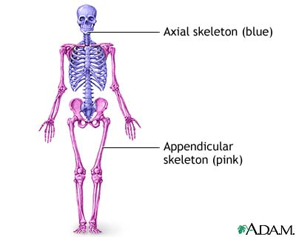
- Two parts of the skeleton:
- ______________ – Head, neck, and trunk
- ______________________ – arms and legs
- 1. Several body cavities
2. Layers of membranes within cavities
3. Variety of organs and organ systems within cavities
VISCERA = internal organs “visceral organs”
- ____________________ means to disembowel or gut; popular in video games and movies
A. Dorsal Cavity ---Cranial Cavity - ___________, Spinal Cavity - ________________________
B. Ventral Cavity
C. Thoracic Cavity - right and left compartment separated by ____________________. Heart , lungs, esophagus, trachea all found in the thoracic cavity.
D. Abdominopelvic Cavity
---Abdominal cavity - stomach, spleen, liver, gall bladder, small intestine
---Pelvic cavity - part of the large intestine, urinary bladder, reproductive organs
*Thoracic and abdominopelvic cavity separated by ___________________
*The organs within the cavities are surrounded by a type of two layered membrane called the __________________ MEMBRANE
10. The outer layer of each membrane is called the _________________ layer and forms a "lining" against the inner wall of each cavity. The inner layer of each membrane covers the surface of each organ and is called the __________________ layer.
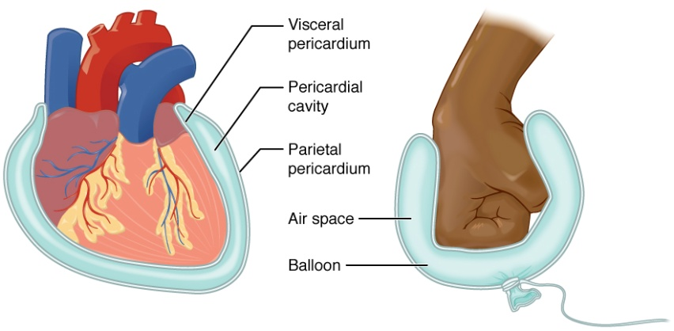
Membranes:
1. Pleura (or pleural membrane) - surrounds the _____________
--outer layer = ______________ pleura
--inner layer = ______________ pleura
2. Pericardium (or pericardial membrane) - surrounds the ____________
--___________ layer = parietal pericardium
--__________ layer = visceral pericardium
3. ____________________ (or peritoneal membrane) - surrounds all the organs within the abdominopelvic cavity
--outer layer = parietal peritoneum
--inner layer = visceral peritoneum
*Between the layers of each membrane is a lubricating fluid which is called ________________ FLUID
Organ Systems
System | Organs Included | Function
Integumentary
Skeletal
Muscular

Nervous

Endocrine
Digestive
Circulatory
Lymphatic
Urinary
Reproductive

Anatomical Terminology – standing ____________, facing ______________, arms at side, palms facing ____________

Superior – towards the ___________, or ______________
Inferior – towards the ___________, or _______________
Anterior - _____________ or in front of
Posterior - _____________ or at the back of
Lateral – toward the _________ of the body, or away from the ___________________ of the body
Medial – toward the ________________ of the body
Proximal – closer to the ________ of the limb
Distal – closer to the _____________ or _______ of a limb
Supine – lying face _______________
Prone – lying face ________________

Anatomical Body Planes

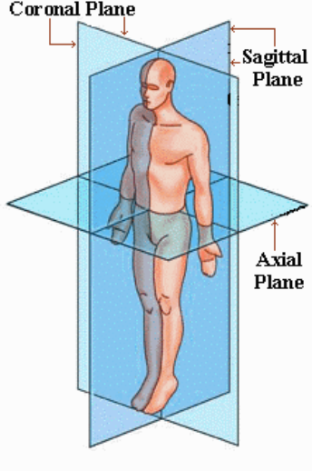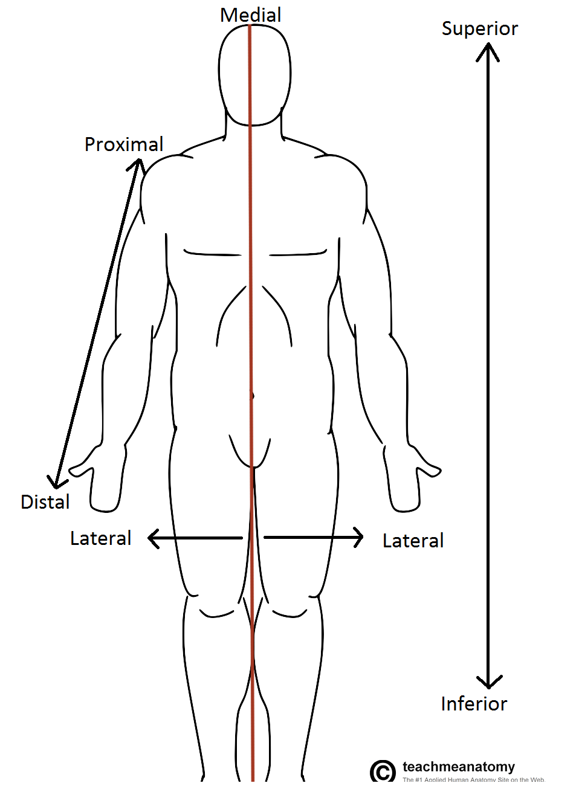

Homeostasis

- ___________________________ describes the body’s ability to maintain relatively stable internal conditions even though the outside world is constantly changing. It indicates a dynamic state of __________________________, or a balance where internal conditions change and vary within narrow limits. Every organ system works to maintain equilibrium inside the body.
- At least three components exist for homeostatic control center:
- Receptor - The receptor is some type of sensor that __________________ and responds to changes in the environment (______________). The receptor responds to the stimulus by sending information to the control center (______________). Examples of receptors can include: _______________________ receptors in the skin, ______________ in the endocrine system, ____________ receptors, nerves.
(2) Control center - The control center (brain) determines the _________ ____________ or ______________ at which a variable must be maintained. The control center analyzes the information it receives from the receptors and then determines the appropriate _______________ or course of action.
(3) Effector - The effector provides the means for the control center’s response to the stimulus. The results of the response then feedback to influence the stimulus by either ___________________ it (negative feedback) so that the entire mechanism is shut off, or ___________________ it (positive feedback) so that the reaction occurs at an even faster rate.
3. Most homeostatic control mechanisms are _______________ _____________________ systems!
EX: Your home heating system. If the thermostat is set at 68°F, the heating system will be turned ON when the house temperature drops below that setting. As it produces heat, the air is warmed. When the temperature goes back up to 68°F or slightly higher, the thermostat sends a signal to turn the furnace off.
What is the receptor in this example? The control center? The effector?
- Because they tend to _____________________ the stimulus and push the levels that a variable must be maintained at farther, _____________________ feedback systems rarely occur. They usually occur infrequently and do not require _____________________ adjustments. What is an example of a positive feedback system?

5. Homeostasis is crucial for good health! In fact, it is so important, that we consider diseases to occur as a result of homeostatic ______________________. As we age, our organs become less ________________ and our internal environments become less _______________. These events make us more susceptible to __________________.

