Homeostasis Guided Notes
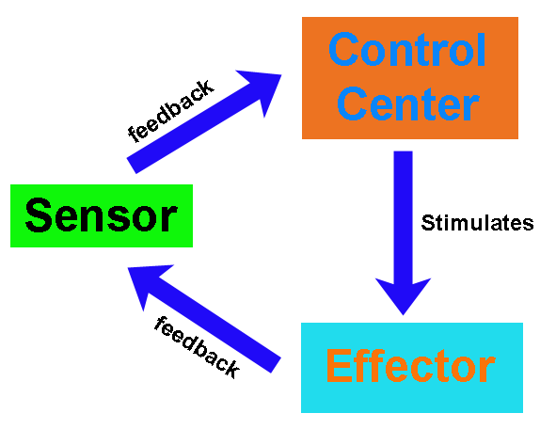
- _______________________ describes the body’s ability to maintain relatively stable internal conditions even though the outside world is constantly changing. It indicates a _________________ state of equilibrium, or a balance where internal conditions change and vary within _________________ limits. Every organ system works to maintain equilibrium inside the body.
- At least three components exist for homeostatic control center:
(1) ____________________
(2) ____________________
(3) ____________________
- The receptor is some type of sensor that ______________ and ________________ to changes in the environment (____________________). The receptor responds to the stimulus by sending information to the control center (____________). Examples of receptors can include: __________________ receptors in the skin, ____________ in the endocrine system, pain receptors, nerves, etc
- The control center (___________) determines the _________________ or level that a variable must be maintained at. The control center analyzes the information it receives from the _________________ and then determines the appropriate __________________ or course of action.
- The ________________ provides the means for the control center’s response to the stimulus. The results of the response then feedback to influence the stimulus by either depressing it (________________ feedback) so that the entire mechanism is _________ ______ or enhancing it (___________ feedback) so that the reaction occurs at an even _____________ rate.
- Most homeostatic control mechanisms are ______________feedback systems!
EX: Your home heating system. If the thermostat is set at 68°F, the heating system will be turned ON when the house temperature drops below that setting. As it produces heat, the air is warmed. When the temperature goes back up to 68°F or slightly higher, the thermostat sends a signal to turn the furnace off.
What is the receptor in this example? The control center? The effector?
___________________________________________________________________________________________

- Because they tend to ____________________ the stimulus and push the levels that a variable must be maintained at _____________________from their set point, positive feedback systems are more _______, occur infrequently, and do not require ___________________ adjustments.
- Homeostasis is crucial for good health! In fact, it is so important, that we consider _________________ to occur as a result of homeostatic imbalance. As we age, our organs become less __________________ and our internal environments become less _______________. These events make us more _________________________ to disease.

