Anatomy and Physiology
Chapter 1 Review Guide - Introduction to Anatomy and Physiology
1. Define ANATOMY & PHYSIOLOGY
2. List and describe the characteristics of life
3. Know the levels of organization, from simplest to most complex
4. Describe the body cavities, what organs are found in each and be able to identify them on a diagram. (See handouts)
5. Describe the membranes and their locations (parietal vs visceral)
6. Describe the organ systems, their functions, and organs found in each (See concept map)
7. Describe the ANATOMICAL POSITION
8. Know the relative positions
9. Understand the body sections (slices) used to observe internal structures, be able to label them on a diagram (sagittal, transverse, coronal)
10. Describe the body regions and be able to identify them on a diagram (See handout, and quiz)
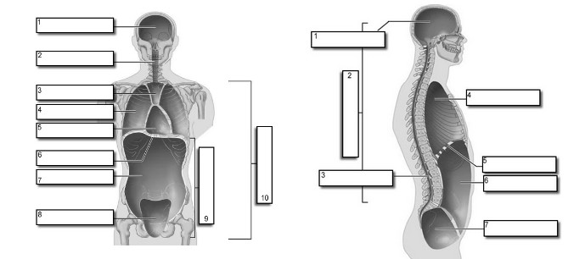

Study Tips
1. Spend at least one hour reviewing your notes, pay special attention to terms
2. Review your handouts, practice naming (labeling) without looking at the answers
3. Take the practice quizzes online (www.biologycorner.com)

